|  |
| --- |
| 新东方在线英语学习 |
| 新概念 2 册 |
| Lesson11 |



扫一扫。更多有趣的英语资讯。

1. turn

# Lesson 11 单词讲解

n. 行为，举止 One good turn deserves another.

n. 轮流的机会 It’s my turn. / My turn had come.

v. 旋转 turn left / right / round

v. 变得 Her face turned red.

1. deserve v. 应得到，值得

He worked really hard, and he deserved the promotion. You deserve it!

1. salary n. 工资

Wages 按件计费

1. immediately adv. 立刻

at once

lawyer n. 律师

bank n.银行

# Lesson 11 课文&语法讲解

**Key points:**

**复习 2－10 课**

* + L2 一般现在时 现在进行时
  + L3 一般过去时
  + L4,5 现在完成时
  + L7 过去进行时

1. I was having (have) dinner at a restaurant when Tony… came in.
2. Tony worked (work) in a … office years ago, but he is now working at a bank.
3. He gets a good salary, but he always borrows money … and never pays (pay) it back.
4. He has never borrowed money from me.

对比：He never borrowed money from me.

1. While he was eating (eat), I asked him…
2. To my surprise, he (give) me the money immediately.
3. “I have never borrowed any money from you,”..

# Lesson 11 知识拓展

turn on 打开 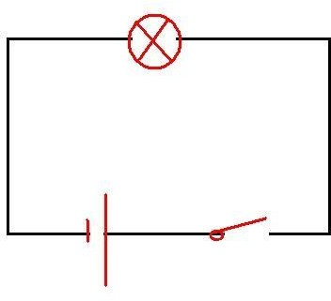 turn off 关闭

turn up

turn down

* You look upset. What’s the matter?
* I had my proposal D again.
  1. turned over
  2. turned on
  3. turned off
  4. turned down (2011 江苏 30)

Key points:

复习 2－10 课

* L2 一般现在时 现在进行时
* L3 一般过去时
* L4,5 现在完成时
* L7 过去进行时复习时态：

一般现在时一般过去时现在进行时过去进行时现在完成时复习时态：

一般现在时 do / does

一般过去时 did

现在进行时 am/is/are + doing

过去进行时 was/were + doing

现在完成时 have/has + done

* Jack always goes to work by car.
* Yesterday afternoon his car broke down.
* Now he is taking a bus to work.
* He has never done that before.
* It rained heavily last night.
* While I was running to the bus station, a car stopped next to me.
* I found that it was my friend Tom.
* He drove me home.
* I have had breakfast.
* You have already told me.
* My sister has not finished her homework.
* I have lived here for … years.
* We have studied English for … hours.

1. 我正在一家饭馆吃饭，托尼走了进来
2. 托尼曾在一家律师事务所工作，而现在正在一家银行上班
3. 他的薪水很高，但是他总向别人借钱，并且从来不还
4. 他从来没像我借过钱
5. 当他吃饭时，我提出像他借20英镑
6. 令我惊奇的是，他立马把钱借给了我
7. 我还从未像你借过钱，所以 你可以替我付晚餐的钱了